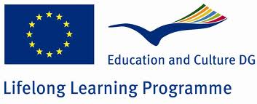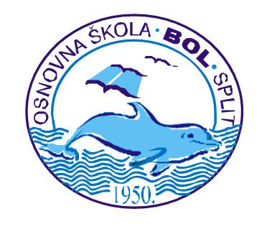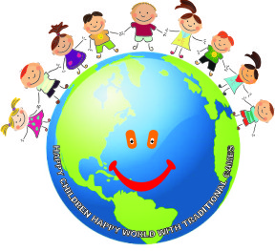

CROATIA

questionnaire 3
Hello!
Your school is taking part with other European schools in a Comenius project “Lifelong Learning Programme”. We would like to learn more about you and assess how much you know about the topics in the project. To do that please answer some questions.

What is the title of the Project which will be carried out in your school? Mark the correct answer:
X “Play and Think with Intercultural Anecdotes”
X “Happy Children, Happy World with Traditional Games” 100%
X “We Play and Have Fun with International Friends”
X “We Know Each Other for so Long – what do we know about European countries”
Enumerate the countries which take part in the Project with your school?
Right answer 58%
Partial answer 37%
No answer 5%
Please mark the partner countries that have been visited so far on the map underneath. Trace the borders of the countries with colour pencil and write its name.

Right answer 41%
Partial answer 47%
No answer 12%

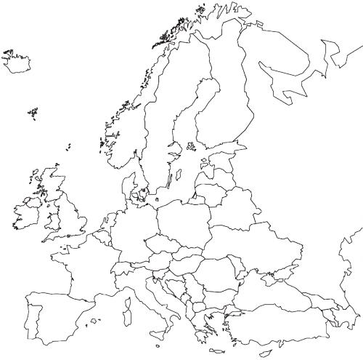
Below you will find the capitals of various countries. Please find the capitals of our partner countries and write the name of the country next to it.

Right answer 49%
Partial answer 45%
No answer 6%

- Ankara - | - Zagreb -
- Warsaw - | - Prague -
- Berlin - | - Paris -
- Wienna - | - Vilnius -
- Sofia - | - Lisboa -
- Madrid - | - London -
- Budapest - | - Athens –

Have you met any friends from partner countries during the project?
X YES 11%
X NO 89%
If YES, please write:
- in which country does he/she live - Hungary, UK, Portugal, Czech Republic, Poland, Turkey
- how do you communicate with him/her/them – In English by Facebook and e-mail
Did you participate in mobility to any country?
X YES 11%
X NO 89%
If YES say
- where? Hungary, UK, Portugal, Czech Republic……………………………
- mark which answer describes the best this visit and you participation in it (you can mark more than one answer)
- - I met new friends from various countries - 12
- - I learned how people live in that country - 12
- - I understood that it is worth learning foreign languages - 3
- - I saw interesting monuments - 5
- - this visit was a great adventure - 12
- - I became friends with the host family - 10
- - I didn’t like it - 0
- - I don’t want to go abroad any more - 0
- - thanks to this visit I had opportunity to go abroad for the first time-2
Any other answers according to your feelings but not mentioned above:
…………………………………………………………………………………..
………………………………………………………………………………….
………………………………………………………………………………….
Thanks to taking part in the Project I learn languages more eagerly than before?
X YES 42%
X NO 58%
If YES, then say:
- What language is it? English
- My grade at the end of the year in comparison to the term grade is:
X BETTER 63% No answer 1%
- WORSE
X THE SAME 25%
Do you have an email?
X YES 81% No answer 4%
X NO 15%
If YES (81%), do you write with somebody who lives abroad?
X YES 35%
X NO 65%
Did you prepare a presentation in Power Point during the duration of the project?
X YES 67 %
X NO 33%
Did you use the Internet to fulfil the tasks of the project?
X YES 72%
X NO 28%
If YES write what did you use it for? To find info about gastronomy, costume, traditions, culture, language of partner countries………………………..
…………………………………………………………………………………
…………………………………………………………………………………
Did you learn any phrases in any foreign languages?
X YES 11%
X NO 89%
If YES please write this phrase, translate it and write what language is it.
………………………..
……………………………………………………………………………….
………………………………………………………………………………..
What games did you learn or reminded of thanks to the participation in the project?
List them.
Pebble game 3% BLACK MARY 39% Karet 90%

……………………………………………………………………………………
Did you play any game or play which was presented by your partners from other countries??
X YES 37%
X NO 63%
If YES please write (describe) about one of them and say which country it comes from Hungary, Lithuania, Czech Republic …………………………………
…………………………………………………………………………………
…………………………………………………………………………………

Did you enjoy taking part in the project and working by using the project method?
X YES 78% No answer 5%
X NO 17%
If YES say why?
…It is fun
… I can meet new people
… because it’s interesting and we can meet friends from other countries
… because Geography lessons are more interesting

Was your country a host country for the partners?
X YES 100%
X NO 0%
If YES,
- are you in touch with foreign students and what kind of contact is it (mail, post, phone etc.)? Facebook, Instagram, Viber
-if you weren’t a host student did you meet any foreign students who were guests in your school (how did you meet him/her/them?) Are you still in touch with him/her/them? My classmate was their host; we were at the workshop together
………………………………………………………………………………………….
Thanks to taking part in the project and visits did you broaden your knowledge about the history, culture, tradition, cusine of foreign countries?
YES 53%
NO 57%
If YES, write what did you get to know
...............................................................................................………………….
Which country are those dishes traditional in?
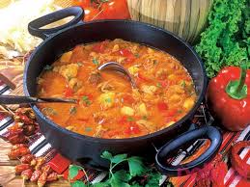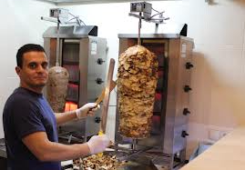
Fish and chips goulash/stew kebab
…………………. ………………… …………………….

Right answer 79% Partial answer 21%

Where is this monument? Write the name of the country

……………….. …………………………. …………….

Right answer 37% Partial answer 55% No answer 8%

Would you like to participate in a similar Project in the future?
X YES 92%
X NO 8% No answer 0%
If YES please write how would you entourage other students to participate in it?
It will be interesting!

What did you like in the project most?
Meeting new friends, travelling abroad, learning about their school obligations

Thank you for the answers.

