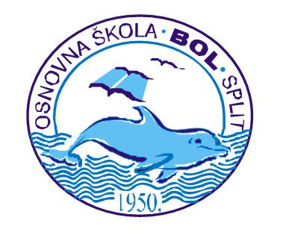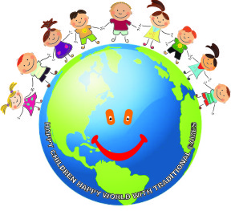

CROATIA

questionnaire 2

Hello!
Your school is taking part with other European schools in a Comenius project “Lifelong Learning Programme”. We would like to learn more about you and assess how much you know about the topics in the project. To do that please answer some questions.

What is the title of the Project which will be carried out in your school? Mark the correct answer:
X “Play and Think with Intercultural Anecdotes”
X “Happy Children, Happy World with Traditional Games” 100%
X “We Play and Have Fun with International Friends”
X “We Know Each Other for so Long – what do we know about European countries”
Enumerate the countries which take part in the Project with your school?
Right answer 52%
Partial answer 33%
No answer 15%
Please mark the partner countries that have been visited so far on the map underneath. Trace the borders of the countries with colour pencil and write its name.

Right answer 9%
Partial answer 66%
No answer 25%

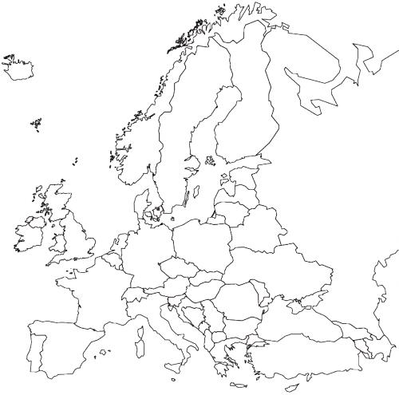
Below you will find the capitals of various countries. Please find the capitals of our partner countries and write the name of the country next to it.

Right answer 42%
Partial answer 45%
No answer 12%

- Ankara - | - Zagreb -
- Warsaw - | - Prague -
- Berlin - | - Paris -
- Wienna - | - Vilnius -
- Sofia - | - Lisboa -
- Madrid - | - London -
- Budapest - | - Athens –

Have you met any friends from partner countries during the project?
X YES 7%
X NO 93%
If YES, please write:
- in which country does he/she live - Hungary, UK
- how do you communicate with him/her/them – In English by email or facebook
Did you participate in mobility to any country?
X YES 7%
X NO 93%
If YES say
- where? Hungary, UK………………………………………………
- mark which answer describes the best this visit and you participation in it (you can mark more than one answer)
- - I met new friends from various countries - 5
- - I learned how people live in that country - 5
- - I understood that it is worth learning foreign languages - 2
- - I saw interesting monuments - 3
- - this visit was a great adventure - 5
- - I became friends with the host family - 5
- - I didn’t like it - 0
- - I don’t want to go abroad any more - 0
- - thanks to this visit I had opportunity to go abroad for the first time-1
Any other answers according to your feelings but not mentioned above:
…………………………………………………………………………………..
………………………………………………………………………………….
………………………………………………………………………………….
Thanks to taking part in the Project I learn languages more eagerly than before?
X YES 40%
X NO 60%
If YES, then say:
- What language is it? English
- My grade at the end of the year in comparison to the term grade is:
X BETTER 63% No answer 1%
- WORSE
X THE SAME 25%
Do you have an email?
X YES 79% No answer 5%
X NO 16%
If YES (79%), do you write with somebody who lives abroad?
X YES 33%
X NO 67%
Did you prepare a presentation in Power Point during the duration of the project?
X YES 52 %
X NO 48%
Did you use the Internet to fulfil the tasks of the project?
X YES 65%
X NO 35%
If YES write what did you use it for? To find info about traditions, culture …..
…………………………………………………………………………………
…………………………………………………………………………………
Did you learn any phrases in any foreign languages?
X YES 10%
X NO 90%
If YES please write this phrase, translate it and write what language is it.
………………………..
……………………………………………………………………………….
………………………………………………………………………………..
What games did you learn or reminded of thanks to the participation in the project?
List them. BLACK MARY 37% DAY and NIGHT 47%
IDE MACA OKO TEBE 16%
……………………………………………………………………………………
Did you play any game or play which was presented by your partners from other countries??
X YES 25%
X NO 63%
If YES please write (describe) about one of them and say which country it comes from Hungary - A cat and a mouse …………………………………
…………………………………………………………………………………
…………………………………………………………………………………

Did you enjoy taking part in the project and working by using the project method?
X YES 68% No answer 10%
X NO 22%
If YES say why?
…It is interesting
… I can meet people from various countries
… because there were people from other countries
… because I don’t get bored during lessons and I’m interested in learning about other countries

Was your country a host country for the partners?
X YES 100%
X NO 0%
If YES,
- are you in touch with foreign students and what kind of contact is it (mail, post, phone etc.)? Mail, Facebook
-if you weren’t a host student did you meet any foreign students who were guests in your school (how did you meet him/her/them?) Are you still in touch with him/her/them? They were in our school and we went to the trip together and sightseeing tour; my neighbour was their host; we were at the workshop together……………………………………………………………….
………………………………………………………………………………………….
Write the name of the country under its flag
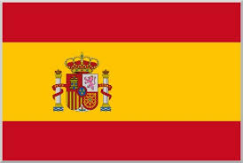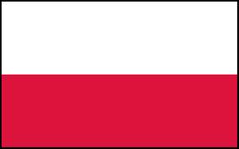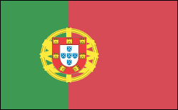

…………………. ………………………… ………………… …………………….
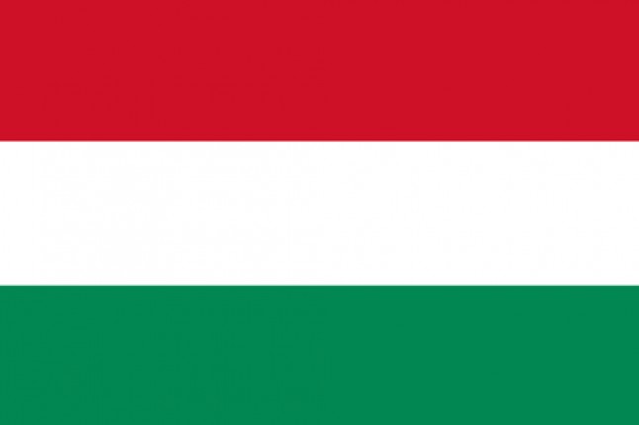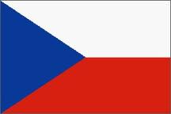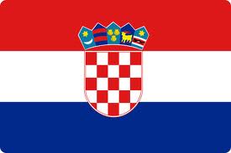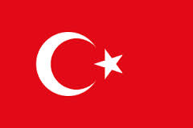

…………………… …………………. ……………………….. …………………..
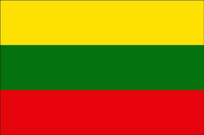 Right answer 40% Partial answer 60%

…………………….
Which country are those dishes traditional in?
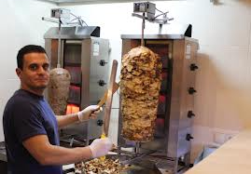
Fish and chips goulash/stew kebab
…………………. ………………… …………………….

Right answer 75% Partial answer 25%

Where do the dancers come from? Write the name of the country
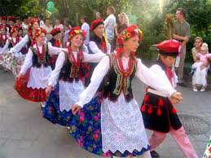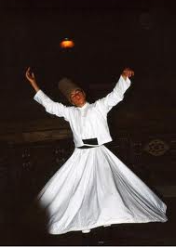
……………….. …………………………. …………….

Right answer 25% Partial answer 60% No answer 15%

Do you want to participate in the Project during the second year of its duration?
X YES 70%
X NO 30% No answer 0%
If YES please write how would you entourage other students to participate in it?
It will be interesting!
It is good to meet new friends and learn new things.

Thank you for the answers.

