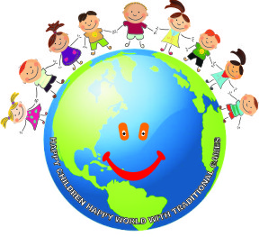
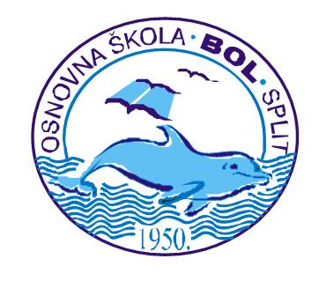

CROATIA
questionnaire 1
Hello!
Your school is taking part with other European schools in a Comenius project “Lifelong Learning Programme”. We would like to learn more about you and assess how much you know about the topics in the project. To do that please answer some questions.

What is the title of the Project which will be carried out in your school? Mark the correct answer:
- “Play and Think with Intercultural Anecdotes”
- “Happy Children, Happy World with Traditional Games”x
- “We Play and Have Fun with International Friends”
- “We Know Each Other for so Long – what do we know about european countries”
right answers: 53%
wrong answers: 47%
Schools from which countries will be your school’s partners? Mark the countries.
- Slovakia  - Greece  - Turkey  - Belgium  - the Czech Republic  - Hungary  - Great Britian(Wales) | - Portugal  - Spain  - Italy  - Croatia  - Lithuania  - Poland  - Austria
right answers: 37%
wrong answers: 63%
Please mark the partner countries on the map underneath. Trace the borders of the countries with colour pencil and write its name.
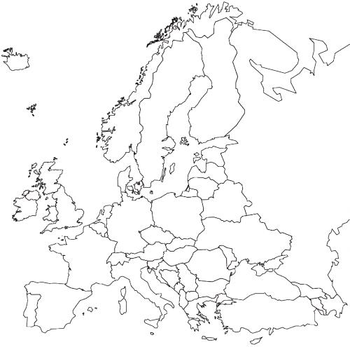
right answers: 40%
wrong answers: 60%

Below you will find the capitals of various countries. Please find the capitals of our partner countries and write the name of the country next to it.
- Ankara - | - Zagreb -
- Warsaw - | - Prague -
- Berlin - | - Paris -
- Wienna - | - Vilnius -
- Sofia - | - Lisboa -
- Madrid - | - London -
- Budapest - | - Athens -
right answers: 39%
wrong answers: 61%
Do you have a friend or a relative who lives abroad? .
- YES
- NO
If YES, please write:
- in what country does he/she live - Bosnia, Germany, USA, Australia .
- how do you communicate with him/her – Skype, email, Facebook……………
YES: 23%
NO: 77%
Have you ever been abroad (on holiday, trip, with parents etc.)?
- YES
- NO
If YES say where? …Bosnia, Austria, Italy, UK…………………………………
……………………………………………………………………………….
YES: 52%
NO: 48%
Do you learn foreign languages at school?
- YES
- NO
If YES, then say:
- What language is it? …English, German……………………………………
- Do you like learning it?...Yes.......................................
- What grade did you get at the end of last year? ………….
- If you had a chance to talk to or write with somebody in language you learn , would you learn it more eagerly? …Yes………………………………………..
YES:100%
NO: 0%
Do you have an email?
- YES
- NO
If YES, do you write with somebody who lives abroad?
- YES
- NO
YES: 69%
NO: 31%
Can you prepare a presentation in Power Point?
- YES
- NO
YES: 82%
NO: 18%
Do you use the Internet?
- YES
- NO
If YES write what do you use it for? …to play games, to Google, Facebook ……………………………………………………………………………..
…………………………………………………………………………………
…………………………………………………………………………………
YES: 99%
NO: 1%
Do you know any phrases in any foreign languages?
- YES
- NO
If YES please write this phrase, translate it and write the name of the language. …Guten Tag, Guten Abend, Ciao, Wie heisst du?, (German)……………………………………………………………………………..
……………………………………………………………………………….
………………………………………………………………………………..
YES: 28%
NO: 72%
What games do you play with your friends in your free time?
List them.
… Hide and Seek, Gumi-gumi, football, dodge ball …………………………………………………………………………………
……………………………………………………………………………………
……………………………………………………………………………………

Do you know any games which your grandparents played?
- YES
- NO
If YES please write (describe) them. … the Mill, Pebble game, ………………………………………………………………………………
…………………………………………………………………………………
…………………………………………………………………………………
YES:15%
NO: 85%
Do you know any games or plays which are played by your friends in other countries?
- YES
- NO
If you know please write what game it is and describe its rules. …
Hopscotch, the Mill, Hide and Seek, Dodge ball ……………………………………………………………………………..
………………………………………………………………………………..
……………………………………………………………………………….
YES:17%
NO: 83%
Do you like working in a team/group?
- YES
- NO
YES:65%
NO: 35%
Have you ever worked by using the project method?
- YES
- NO
If YES what was its topic?
…………………………………………………………………………………
YES:37%
NO: 63%
Would you like to travel to partner countries?
- YES
- NO
If YES, please say:
- why?...to travel for free, to meet new friends, to learn about other countries and tradition............................................................................................................
………………………………………………………………………………........
……………………………………………………………………………………
- to which country would you like to go? Say why.
………UK – to speak English and meet the Queen, to visit London Eye
………Portugal – to see the ocean ……………………………………………………………………
……………………………………………………………………………………
……………………………………………………………………………………
YES:93%
NO: 7%
Thank you for the answers.

