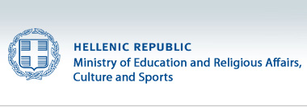
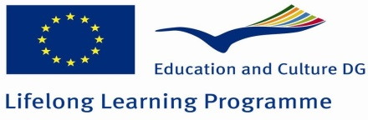

8th PRIMARY SCHOOL of ZOGRAFOU
MAKRYGIANNI 46- IOKASTIS
15772 ZOGRAFOU-ATHENS GREECE

SOCRATES COMENIUS MULTILATERAL SCHOOL PROJECT

MEETING IN ZOGRAFOU ATHENS (GREECE)

“ The Source of our Health”
11th-15th MARCH 2013
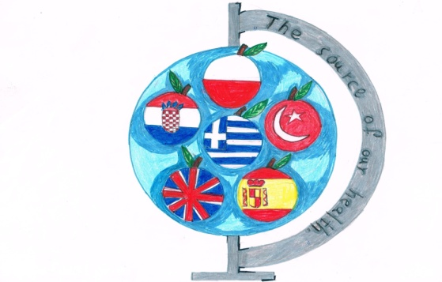
REPORT

ATHENS 2013
“The Source of our Health”
The second work meeting on the Comenius Multilateral School Project “The Source of our Health” took place in the 8th Primary School of Zografou, in Athens from 11th to 15th of March 2013. This meeting was attended by 30 guest teachers from the following associate schools:
- CEIP Ntra. Sra De Fatima, Molina de Segura, Murcia, Spain
- Osnovna Skola Bol, Split, Croatia
- Primary School No 8, Jelenia Gora, Poland
- Nazilli Kizildere llkogretim Okulu, Nazilli, Turkey
- St. Richards Catholic Primary School, Chichester, United Kingdom
and by all the Greek teachers from 8th Primary School of Zografou, Athens,Greece.

We strongly believe that the participation and the active involvement of all the members of the school committee in this project will yield multiple benefits, because, through the process, both students and teachers are going to:
- learn about healthy nutrition and habits
- learn to choose our food and our life style according to criteria and not by chance
- realize that the human needs for health and life quality are common
- break down stereotypes
- learn through diversity
- become members of a larger community, the European community
- use the English language and ICT to communicate

WELCOME TO 8th PRIMARY SCHOOL
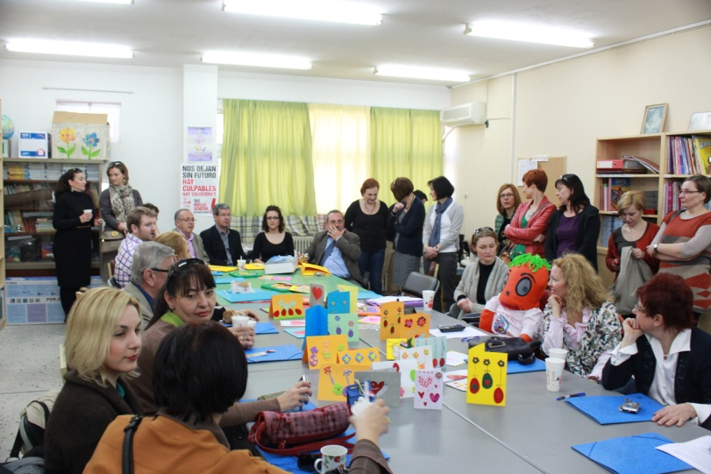
On Monday 11th of March 2013, our guests were welcome by the Mayor of the Municipality of Zografou Mr. Kostas Kalliris, the vice Mayor Mr. Agis Papakonstantinou and the Municipal Councelors Mr Grivas and Mr Kollias.
The Croatian team brought the mascot of the project which will remain in Athens until the next meeting in Poland.
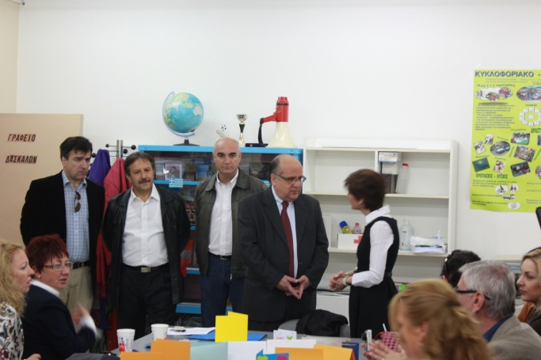
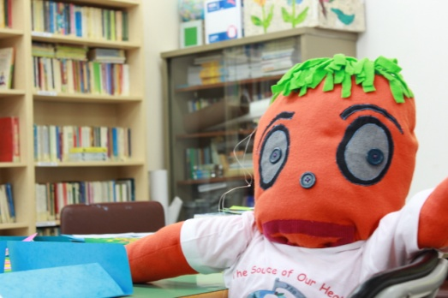

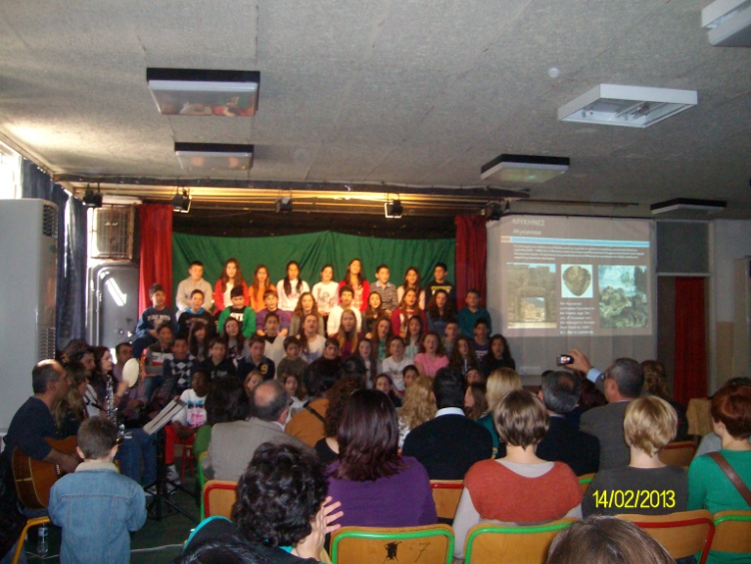
A welcome ceremony had been prepared by all the students of the 8th Primary school. They performed traditional songs from the 6 countries of the Comenius partners in each country’s native language. The children’s choir was accompanied by a group consisting of school teachers who played musical instruments.

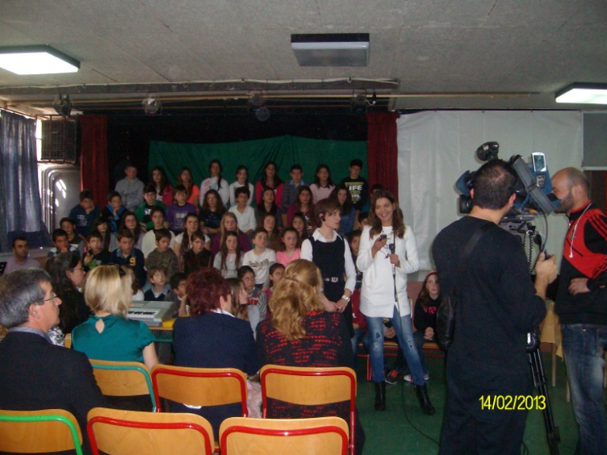
Part of the event was presented live by a nationwide TV Channel (ΣΚΑΙ TV), and there was a report in the evening news on the same channel, too. A journalist of a daily newspaper (KATHIMERINI) took interviews about the subject and the goals of this Comenius project.
A representative from each country addressed the parents and teachers present with
a few words about the project.
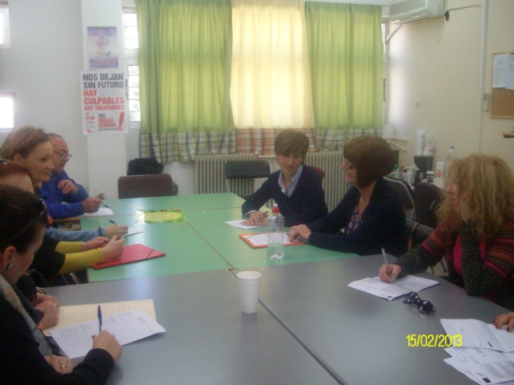
WORKING SESSIONS
During the four days that our meeting lasted we had 4 working sessions in which: a) we discussed about our results and our difficulties during the past 3 months and we exchanged work done by the pupils of all schools which will be displayed on the schools’ Comenius Corners b) we made plans for the next 3 months according to the work programme in our application c) we talked about the next mobility in Poland and

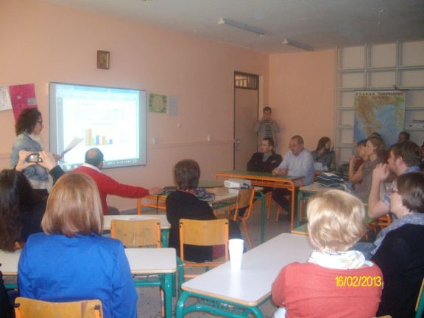
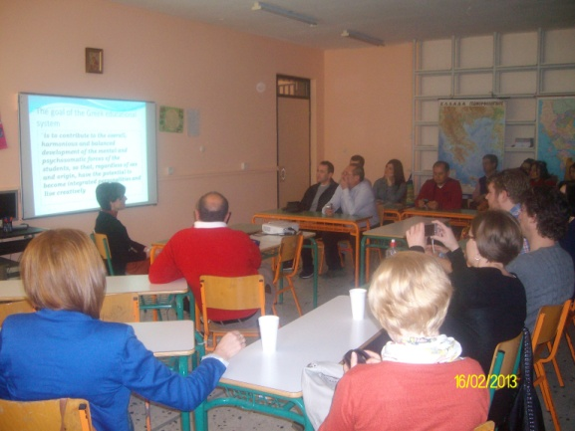

d) in the last session, with all teachers present, the headmistress of 8th Primary school of Zografou, Mrs Ikkou, presented the Greek educational system. In the same session the Coordinator from Spain, Mr Canovas, presented the results of the questionnaire about the nutrition and hygiene habits of students and their families, which had been applied in February 2013.

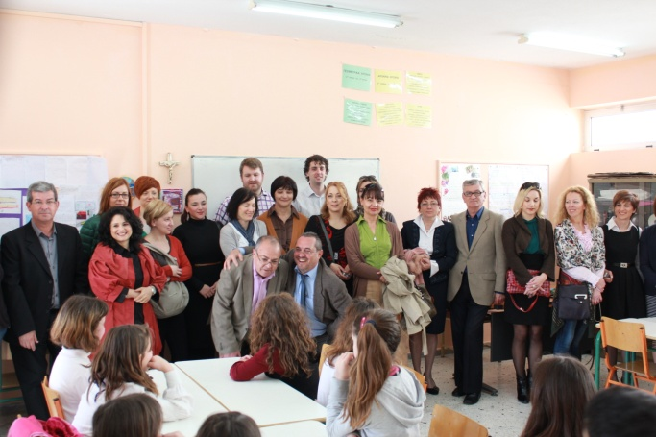
On Monday morning our Comenius partners/guests had a tour of our school. They visited the classrooms and talked with the pupils. They saw the children’s works, teaching materials and course books. All participants, including the pupils, were very happy to use the English language to communicate with each other.

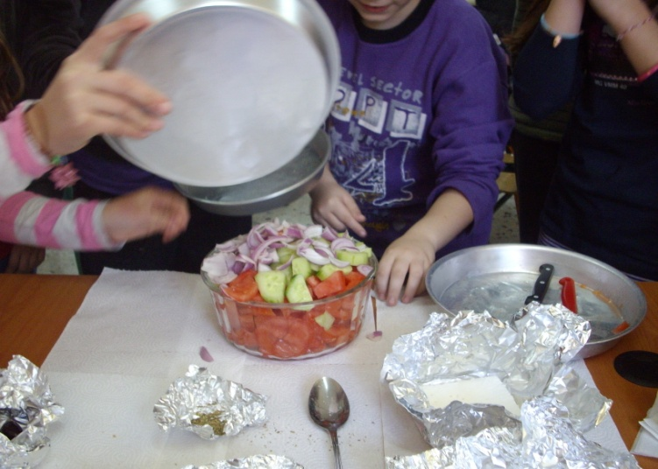
On Tuesday 12th March they visited the classrooms in groups, where the students prepared the Greek traditional salad. The recipe was given to the guests on placemats.

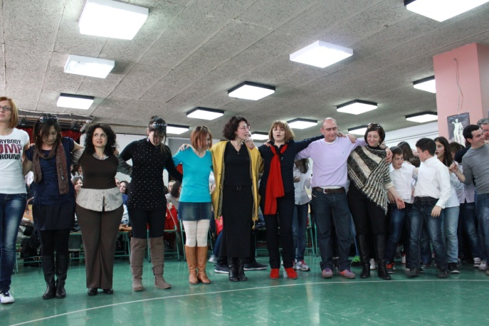
CLOSING CEREMONY
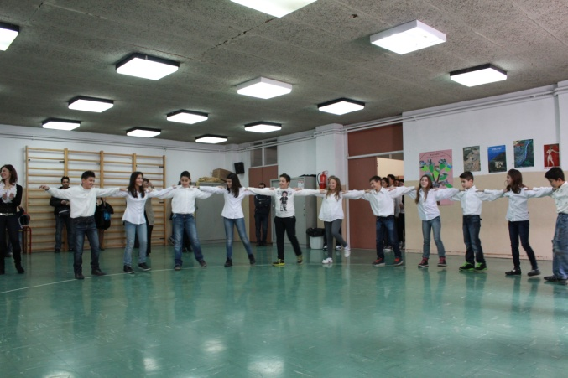
On Thursday the 14th of March in the Assembly Hall of our school the pupils of all classes performed traditional dances from all the regions of Greece. This ceremony was also attended by the parents. The dances were taught during P.E. classes, and it is a part of the Educational Curriculum. At the end, students, guests, school teachers and parents danced a traditional Greek dance all together.

CONCLUSIONS
During these days the teachers had the opportunity to come closer through several activities, visit museums, the Parthenon, the historical centre of Athens, the ancient Temple of Poseidon on Cape Sounion and Kessariani Byzantine Monastery. We shared thoughts, feelings, ideas, everyday life problems, we talked about the educational reality in each country and we found out more similarities than differences. These five days were a great experience because under the Greek sun we let our senses be possessed by the highest human values which cannot be counted by numbers.
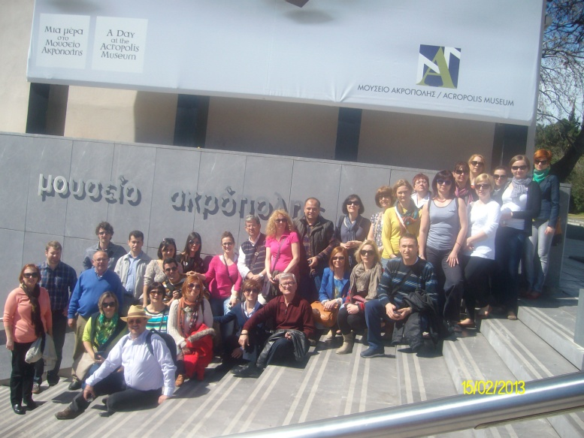
PHOTO GALLERY

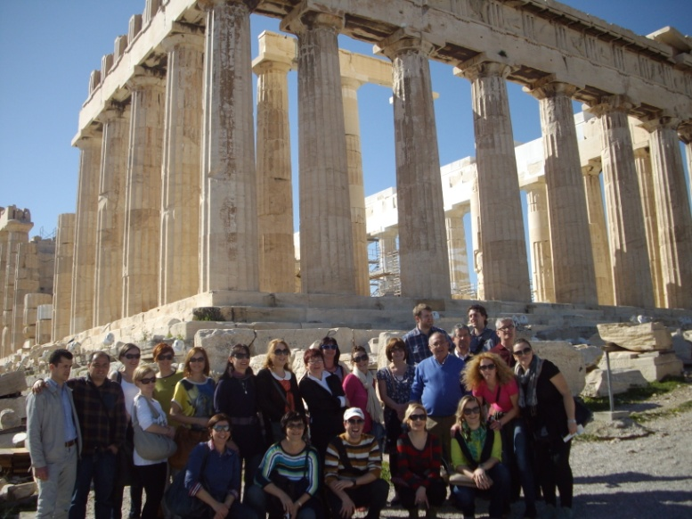

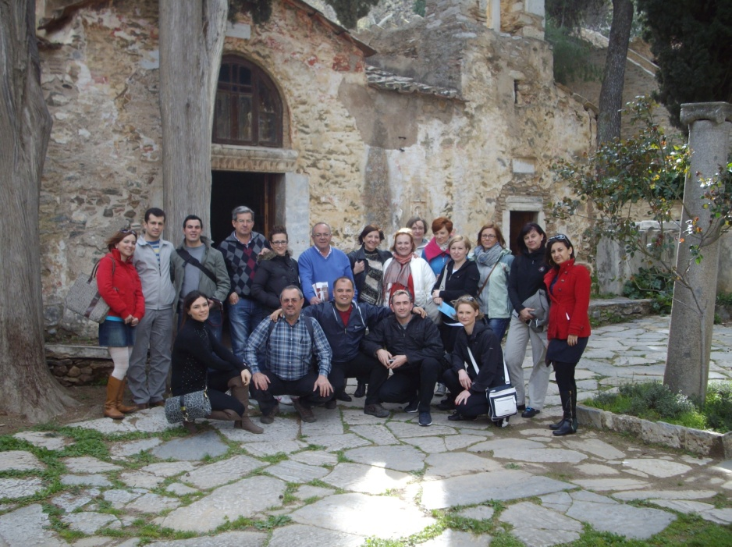

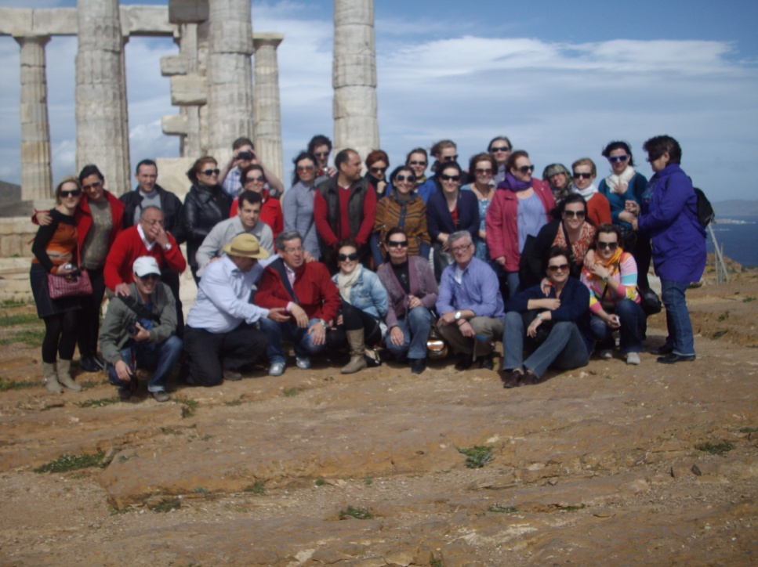

You can watch the part of the evening news on the following link http://www.skai.gr/player/TV/?MMID=237720

